The Blueprint
Who is your Customer?

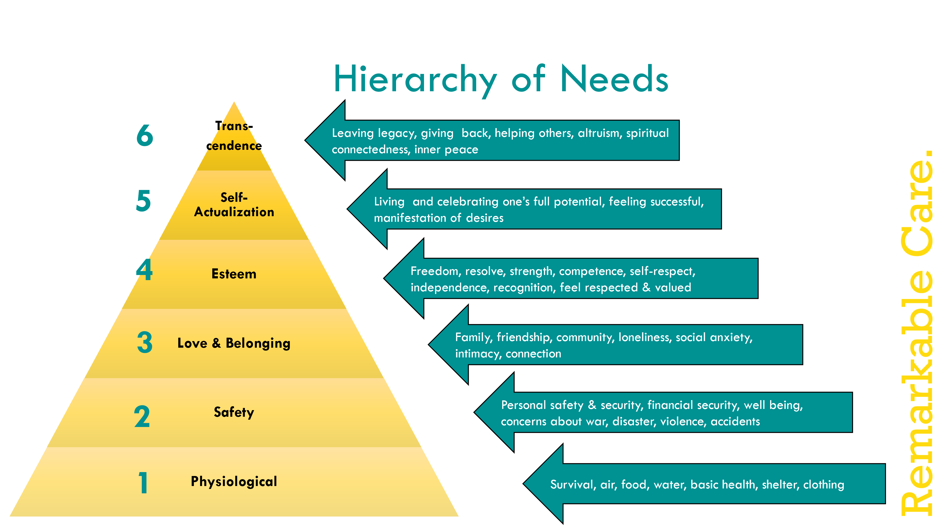

Level 1 – Physiological
Challenges | Opportunities
- Is there worry or concern about survival?  - Is there physical pain?  - Is there sickness?  - Is there food insecurity?  - Is there worry about acquiring or keeping housing?  - Does everyone in the home have clothing to keep them warm? | - What are their physical body strengths that could be called upon?  - What’s good about their physical environment?  - What’s good about their health?  - What’s good about their ability to nourish themselves?  - What’s good about their overall physical well being?

Level 2 – Safety
Challenges | Opportunities
- Is there worry Are there safety concerns? In the home? Outside the home?  - Is there concern about violence or abuse?  - Are there other worries about safety that are consuming the person?  - Is there financial stability?  - Health insurance risks?  - Is there concern for nutrition?  - Is there worry about getting sick?  - Other safety concerns – political instability, war, violence, natural disaster?  - Are they prepared for an emergency or disaster? | - What safety measures have been implemented in the home?  - What resources are in place to support the patient and family?  - What emergency preparations are in place?  - Is there a need for outside funding of some kind?  - Are there programs that could help?  - What specific measures would increase their level of safety and security (even if we can’t directly provide)?

Level 3 – Love & Belonging
Challenges | Opportunities
- Are they lonely? Do they have family/friends/people who love them present?  - Do they have trouble connecting with others? Getting along with others?  - Might they be feeling rejected, abandoned, or not included in some ways?  - Is there lack of social opportunities?  - Do they experience social anxiety? | - Who do they have family/friends/people who love them present daily/weekly/monthly?  - What are their social activities they enjoy? What social opportunities would they like?  - Where do they experience inclusion and belonging? In what circumstances? With which people?  - What opportunities exist for them to develop connections and belonging with others? Clubs, church, places, networks, organizations, programs, etc.?  What are opportunities to create laughter, fun, and joy with them?

Level 4 - Esteem
Challenges | Opportunities
- Does an illness or disability prevent them from…  - Knowing what they want?  - Doing what they want?  - Saying what they want?  - Moving around independently?  - Picking a passion and engaging in it in the way they’d like  - Feeling independent and free?  - Are they unable to control the environment they are in?  - Are they unable to control their daily activities?  - Do the struggle to know or express their wishes and desires?  - Do they feel like a burden to others? | - What have they accomplished? What are their contributions? What are their strengths and gifts?  - What could they accomplish that would add to their self-esteem?  - What opportunities exist to help them…  - Explore likes and dislikes?  - Express thoughts, feelings, and desires?  - Have more independence and freedom?  - Engaging in something they love?  - Be in greater control of their daily activities  - What could communicate that they are cherished, loved, and valued?  - What are their strengths? How could those strengths be exemplified and celebrated?  - What could you do to communicate respect to them?

Level 5 – Self-Actualization
Challenges | Opportunities
- Do they perceive themselves negatively?  - Do they feel they have failed in some way?  - Do they feel depressed about their life?  - Do they feel unsuccessful?  - Do they feel they have not accomplished something of meaning? | - In what ways do they view themselves as successful?  - In what ways do others view them as successful?  - What do others admire about them?  - What would they celebrate about their life?  - In what ways have they made a difference to others, even if they are unaware?

Level 6 - Transcendence
Challenges | Opportunities
- Are they sad that they have not given back to others in the way they’d like?  - Are they worried they are not leaving the legacy they hoped?  - Are they worried and regretful about how they’ve lived or choices they’ve made?  - Are they bitter and angry?  - Do they blame others and the world for their situation?  - Do they feel they are a victim of a hard life? | - Notice the love they have invoked from others – where have they brought out love and compassion in others?  - In what ways can you see they are at peace? With themselves? With who they are?  - What are the gifts they give to the world?  - What gifts and wisdom have you learned from them?  - How have they inspired others’ greatness? Love? Compassion? Courage? Joy? Healing?

The Wheel of Life

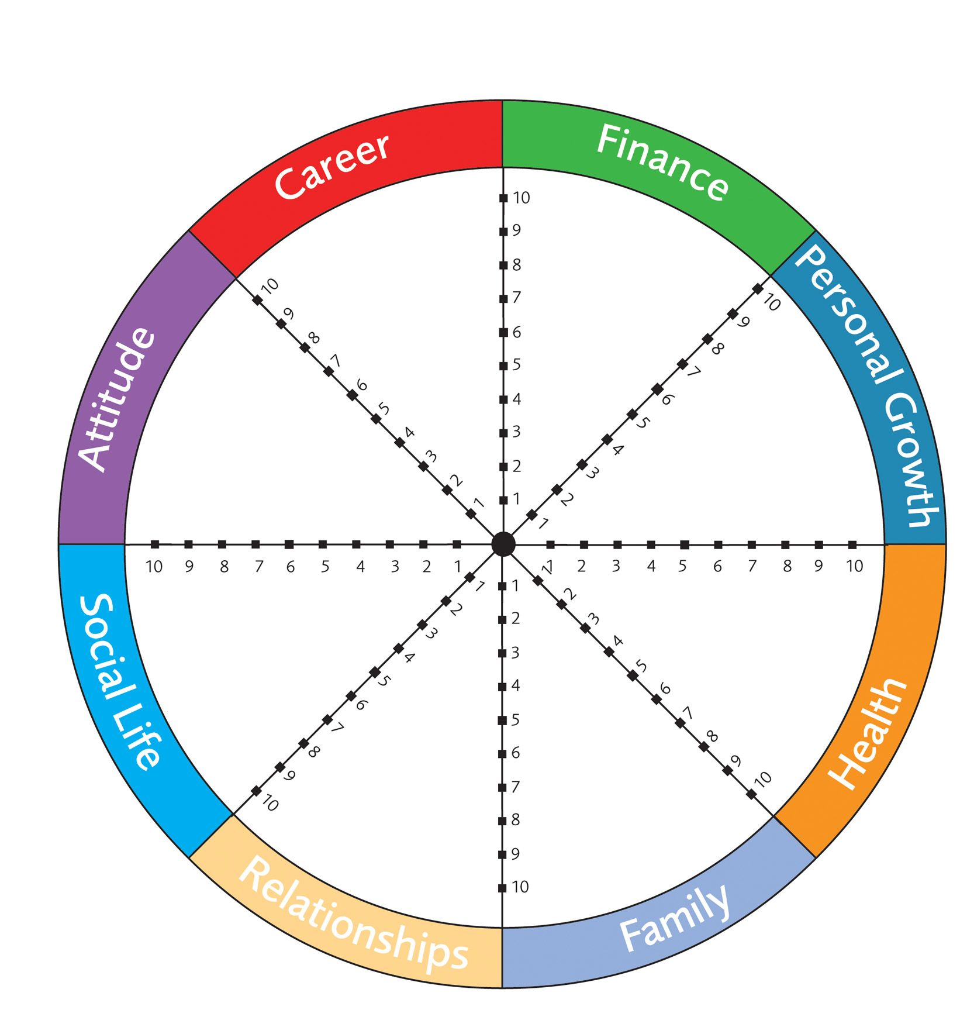

The Curated Care Plan
Who is your Customer?

Step 1 - Fill Up Your Cup
Intentions | Curated Care Questions
- Self-care is the secret ingredient of Remarkable Care Providers.  - If you don’t care for yourself, you won’t be able to care for others. | - In order to support this customer, what intention or thought can I bring to my interaction?  - What is an act of self-care that I can take to fill up my cup?  - What can I do to stoke my inner fire?

Step 2 – Be Prepared
Intentions | Curated Care Questions
- Review the patient’s POC & Curated Care Plan before you begin your shift  - Have supplies on hand,  Be in the mindset of serving Remarkable Care | - Before I meet with my Customer, what information should I review?  - What might I anticipate they will want or need?  - What work can I do in advance to support my customer and myself for our best possible interaction?

Step 3 – Be on Time. Early Even.
Intentions | Curated Care Questions
- Arrive 5 minutes early parked in front of the home.  - Organize yourself.  Arrive smiling at the front door exactly on time. | - Rate yourself on timeliness of arrival.  - Under the best and worst conditions, how long will it take me to get there?  - What reminders could I set to help me get in the car, get on Zoom, or walk down the hall to arrive on time – early even?  - What will you start / stop / keep doing to ensure you arrive a few minutes early?

Step 4 – Enter As Preferred
Intentions | Curated Care Questions
- Enter the home with warm, gentle greeting,  Follow a ritual that meets the needs, wants, and preferences of the patient and family | - How would your customer prefer you enter the physical or virtual space?  - What can you contribute to the environment as you enter?  - What would possibly offend, annoy, or bother your customer that you will avoid?

Step 5 – Anticipate & Fulfill Wants & Needs
Intentions | Curated Care Questions
- Follow the Plan of Care (patients)  - Follow Agenda or Communication Tools (other customers)  - Follow the Curated Care Plan  Listen for spoken and unspoken wants, needs, and preferences. | - Review the Blueprint and Life Wheel  - What can you do to support your customers wants, needs, and preferences?  - What would be small, simple ways you could communicate you care?  - What unmet and unvoiced needs could you fulfill?

Step 6 - Tidy, Brighten, and En-light-en
Intentions | Curated Care Questions
- Make everything you touch better  - Bring light to every person, situation, and environment  - Ensure areas where you work are impeccably neat, clean, and organized | - What activities could you do to ensure things stay organized, neat, and tidy?  - How could you improve the methods of communication between you and other staff members?  - What systems could you implement to improve overall hygiene, efficiency, and outcomes?

Step 7 – Prepare Your Departure
Intentions | Curated Care Questions
- Patient Visits:  - 15 Minutes prior to departure, let your patient know you will be leaving soon  - Ensure your patient has everything they might need or want before you go  - Make sure your area is tidy  - Gather your things  Ensure documentation is complete  - Other Customer Interactions:  - Make sure you know what next steps are  - You know what your responsibilities are  - Ensure everyone on your team has what they need | - How much time do you need to prepare?  - What can you do to make sure you leave things better than you found them?  - What could you do now you might otherwise put off?  - What could you do right now before you depart to ensure your next interaction with this customer is the best it can be?

Step 8 – Fond, Caring Farewell
Intentions | Curated Care Questions
- Give a warm goodbye in the way the customer prefers | - What words could I use right before I leave that would communicate heartfelt trust and caring?  - What words, actions, or behaviors should I avoid?  - What non-verbal action could I take as I leave that sends a caring message?

Step 9 – Review Report & Innovate
Intentions | Curated Care Questions
Clinical Teams:  - Track your day in EMR or through visit documentation notes  - Report new needs, wants, and preferences to Case Manager  - Participate in Monthly Interdisciplinary Team (IDT) Meetings  - Identify new ways to bring Remarkable Care™ to the patient and family  Other Customers:  - Take follow-up actions immediately  Block times in your calendar to take any follow-up actions you cannot take immediately | - Rate yourself (1-5) on timely completion of your work.  - When is your follow-up work due?  - Are there other tools, resources, or people you need to organize or coordinate?  - When do you plan to do the necessary collection of tools, resources, conversations or work?  - Schedule it in your calendar.

Step 10 – Acknowledge Yourself
Intentions | Curated Care Questions
- Give yourself loving acknowledgement for the care you provided to another. “I acknowledge myself for…” | - What could you do at the close of each shift, meeting, work product, or work day to acknowledge and celebrate yourself?  - What would be an act of celebration that would allow you to feel appreciated and celebrated?  - Write a list of self-acknowledgements.

